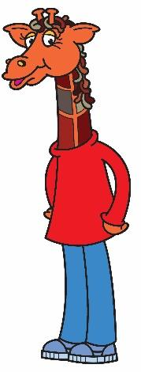

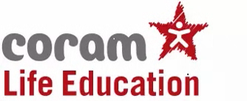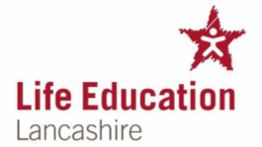

Dear Parents / Carers

**Life Education Lancashire is coming to our school on** **Tuesday 25th March 2025**

Coram Life Education is the leading provider of relationships, health, wellbeing, and drugs education to almost half a million children across the UK, delivered under the strapline ‘Helping Children Make Healthy Choices’.

Life Education Lancashire is a delivery partner of Coram Life Education and provides unique health and drug education programmes teaching children about the wonder of their bodies, how to take care of them, and how drugs (including medicines, alcohol and tobacco) can affect them. Looking after our mental health is also explored and children discuss strategies for self-care.

Children meet Healthy Harold, our giraffe mascot, and his friends, have discussions and watch short films about healthy eating, legal and illegal drugs and their effects, the body and friendships and their influence, and how choices and behaviours can affect dreams and aspirations.

Trained Educators use evidence-based, interactive, creative methods to deliver memorable, informative and age appropriate sessions which assists our school in our work around PSHE (Personal Social and Health Education) and Relationships and Health Education. All programmes support the new DfE statutory requirements for PSHE and are aligned with the National Curriculum.

If you would like to help your child to remember the visit, Harold merchandise may be on sale for £1 whilst Harold is visiting school.

There is an opportunity for parents / carers to come into school to meet the Life Education Educator for a short session to find out more about the content of your child’s programme and to ask any questions you may have. This will be from 8.55am – 9.10am.

If you do have any questions, please contact school and we will be happy to ask the Educator and respond via your child’s teacher.

Yours sincerely

S J Smith

Mrs S Smith

Head teacher and SENCO