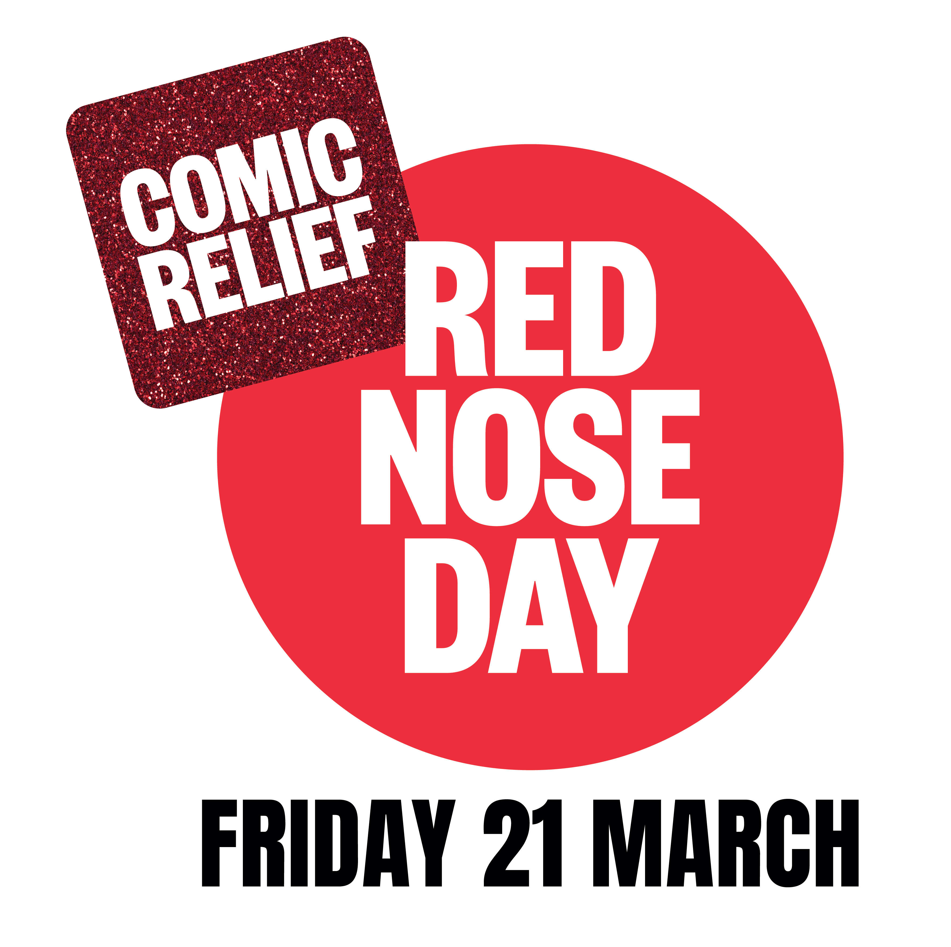

Monday 10th March 2025

Dear Parents / Carers,

Red Nose Day and World Down Syndrome Day

21st March 2025

On Friday 21st March, Sharneyford Primary School, will join thousands of schools up and down the country and do something funny for money for Red Nose Day. As well as this, we will also be marking World Down Syndrome Day which is the same date this year.

In March, Comic Relief hits the big 4-0 and they’re asking the nation to join the party and go big, give big and feel good! Because when we all do a little something funny for money, big beautiful change happens. A donation to Comic Relief this Red Nose Day will support projects that help children be happier, families stronger, women safer, communities prouder and millions of lives fairer.

**What is Red Nose Day?**

* Red Nose Day is an annual fundraising event run by Comic Relief.
* Comic Relief is a UK charity which aims to create a **just world free from poverty**.
* The money raised is used to transform lives in the UK and around the world.

**Why we’re taking part**

* Pupils learn valuable life skills and gain understanding and empathy for others in the world.
* It’s a great way to get together for a giggle.
* Our school can really make a difference to people’s lives.

**Where the money goes**

* **£10** could provide a day of meals and activities for a child during school holidays in the UK
* **£50** could help to provide a young person living in poverty in Zambia with lessons on CV writing and employability skills, helping them to find long-term independence
* **£200** could establish a peer support group for a kinship carer to gain a local support network and companionship in the UK

World Down Syndrome Day is on 21 March every year. It is a global awareness day which has been officially observed by the United Nations since 2012. The goal is to help people understand and support those with Down syndrome better.

The date being the 21st day of the 3rd month was chosen to represent the triplication (trisomy) of the 21st chromosome which causes Down syndrome.

Here's what we’ve got planned:

* **Dress up/ dress down**
* **Bake sale**
* **Red Nose sale**
* **Wear odd socks for World Down Syndrome Day**

We know there’s a lot going on right now and for many people things are really tough.   
But if you can donate, every penny will add up to a life changing difference.

Because people matter. Everyone. Everywhere. Always.

You can support and donate by purchasing a red nose for £2.00, baking cakes, buns and biscuits to sell, wearing non uniform and the colour red for a voluntary donation or by dropping some pennies in the buckets on 21st March.

Thank you for your continued support - you are BRILLIANT!

Yours faithfully,

Mrs S Smith

Head teacher and SENDCo

