 **Holiday Pattern 2025 - 2026**

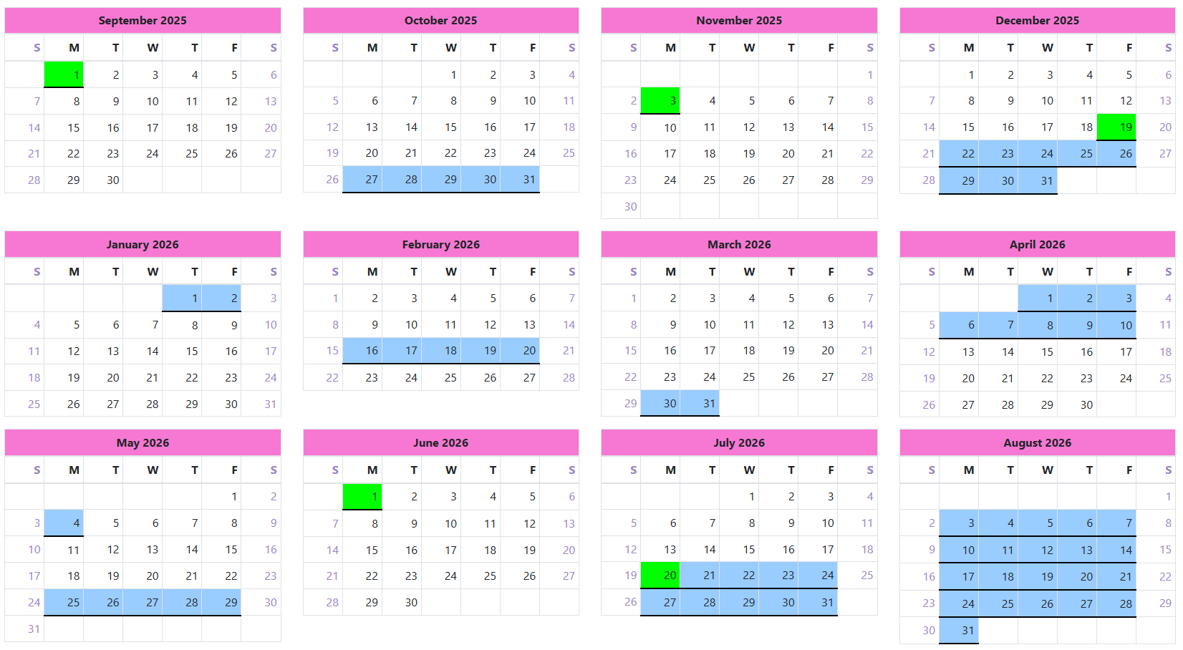

Holidays

Training Day (school closed to pupils)