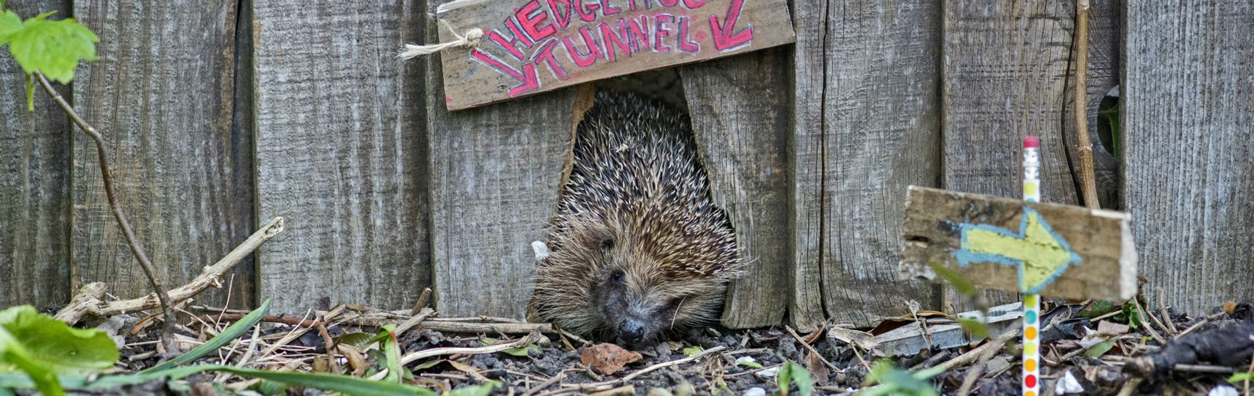

Hedgehogs are small creatures with big appetites!
Feed the hungry hogs in your garden to help them build the energy they need when raising hoglets, and their fat reserves for their long winter hibernation.

With the UK population of hedgehogs declining alarmingly, it’s vital that we give our prickly friends a home in our gardens.

One way to do this is to build a feeding station in your garden with lots of hedgehog-friendly food and water!

You won't get any takers in winter when all your hogs are fast asleep, but you can start your feeding at any other season if there are hogs around.

What you will need
- Shallow dishes
- Water
- Large-lidded plastic or wood box
- Sharp knife
- Saw
- Duct tape
- Bricks

What to feed hedgehogs
- Hedgehog food
- Wet cat or dog food
- Cat biscuits

Step-by-step guide
- Find a safe place for your cafe. It can be on your patio, or it can be hidden in a sheltered spot. Of course, hedgehogs need to be able to get in and out of your garden to start with, so if that isn't yet the case, start by creating nature's highways and byways.
- Get a sturdy box (wood or plastic) with a removable lid for your feeding station. It needs to be big enough for a hedgehog to fit in - a plastic storage box is a popular choice. You can also install a tunnel to prevent cats or foxes stealing the food.
- Create a hedgehog-sized hole at the base of one of the sides of your box. It should be about 13cm square so the hog can get in and out safely. If your box is wooden, you’ll need a saw. If your box is plastic, carefully use a sharp knife. Cover the edges of the hole with duct tape to make sure there are no sharp bits that could hurt your hedgehogs.
- Add your grub. As the sun goes down lay shallow dishes of hedgehog-friendly food and water inside the box. Make sure you don’t put out too much food, as it’s not nice to have leftovers lying around, and just remember that what we provide is supplementary to their natural diet, so do not overfeed your ‘hogs. Never feed hedgehogs milk or bread as they can't digest them and it upsets their stomachs. Also, be aware that putting any food out will attract all sorts of wildlife, not just hedgehogs – this includes predators.
- Add your roof. Put the lid on top of the box and place a brick or two on top of the lid. This will stop a fox tipping the box up or dragging it away.
- Clear away any leftovers in the morning and refill your dishes every evening, or for as long as the food is being eaten. Make sure to wash your hands and thoroughly wash the feeding dishes, as hedgehogs have been known to spread diseases.
- Time to watch. Very quietly as the sun goes down, go out and sit somewhere within view of the box and hopefully you'll be rewarded with a view of this snuffling, grunting little beauty.

