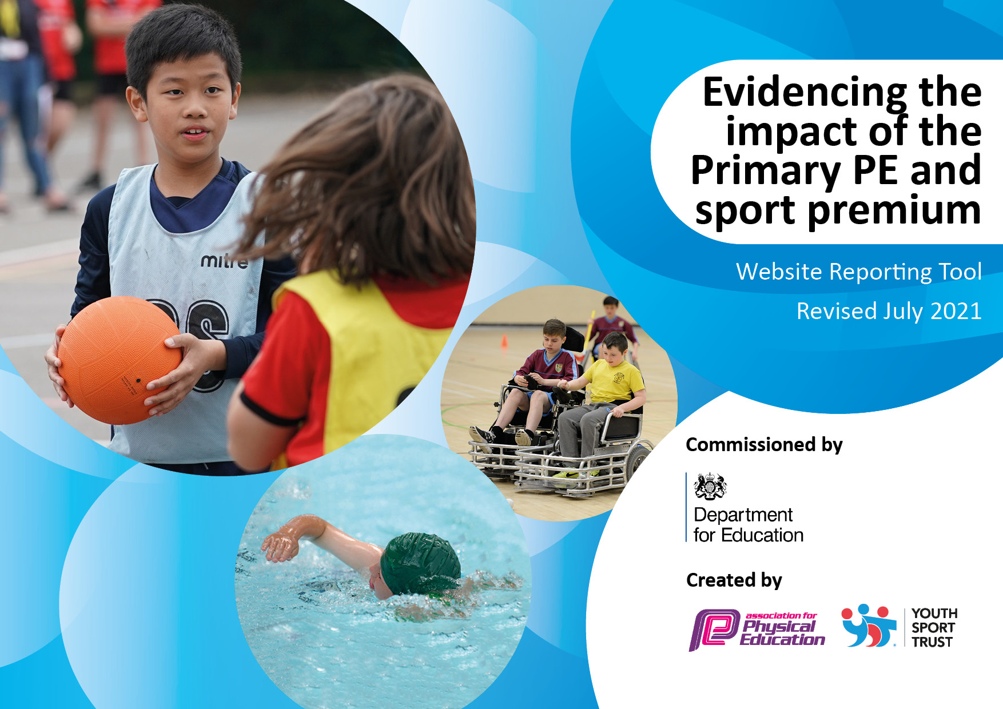
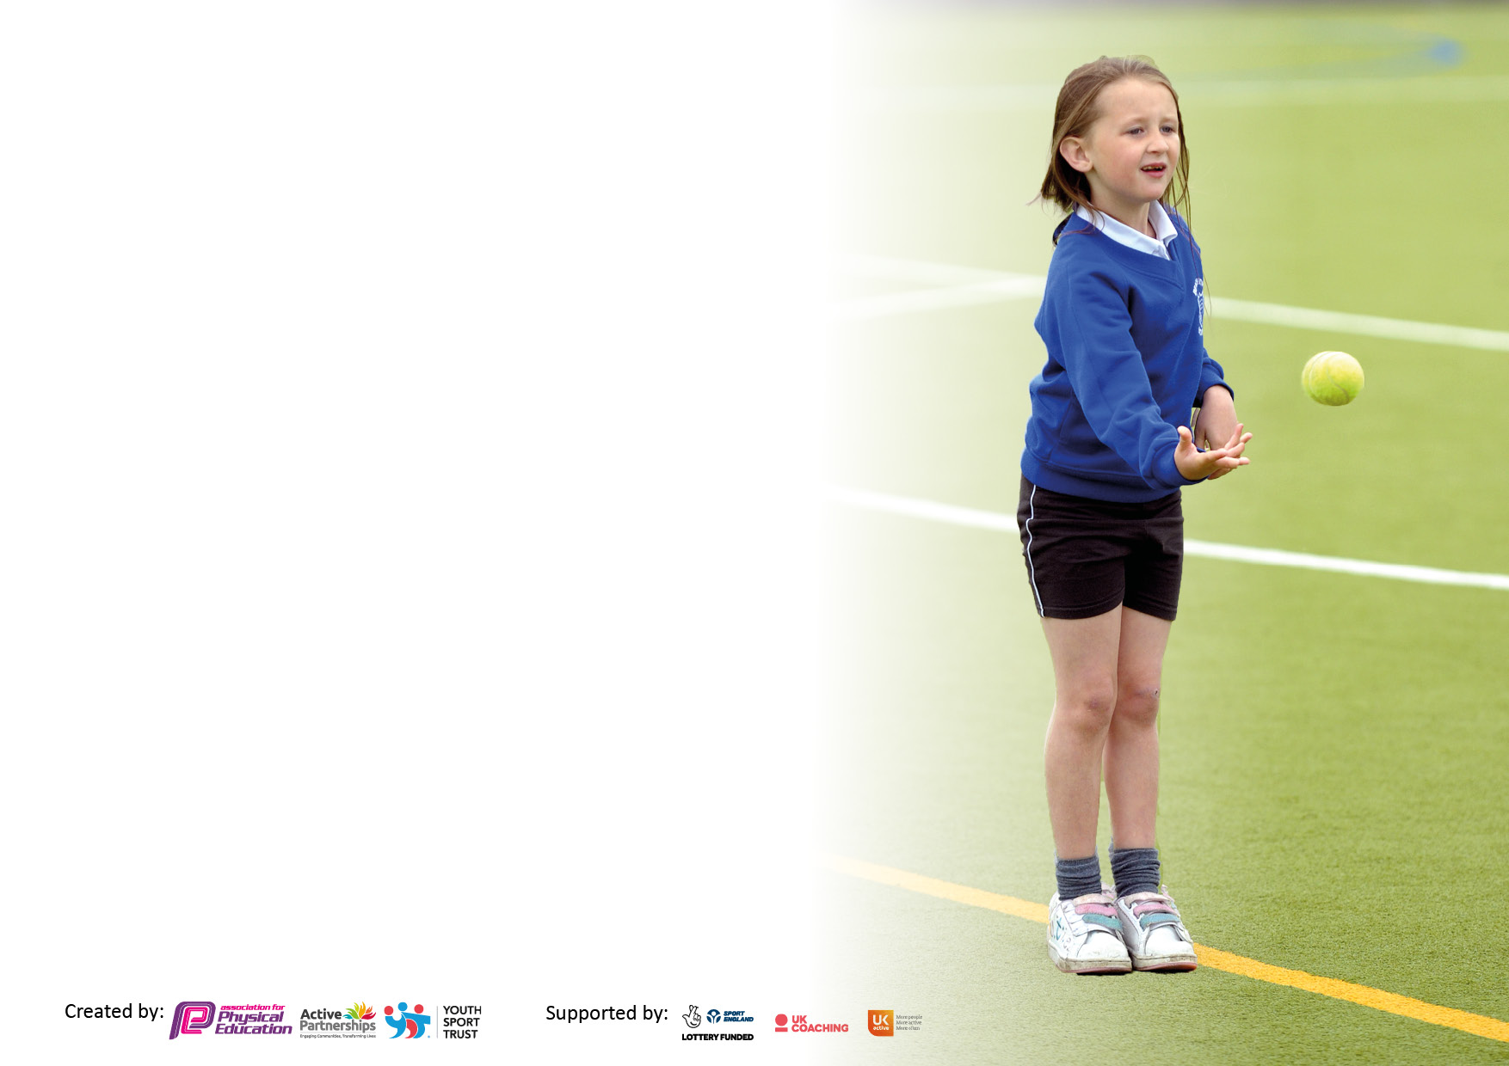

It is important that your grant is used effectively and based on school need. The Education Inspection Framework makes clear there will be a focus on ‘whether leaders and those responsible for governors all understand their respective roles and perform these in a way that enhances the effectiveness of the school’.

Under the Quality of Education Ofsted inspectors consider:
Intent - Curriculum design, coverage and appropriateness
Implementation - Curriculum delivery, Teaching (pedagogy) and Assessment
Impact - Attainment and progress

To assist schools with common transferable language this template has been developed to utilise the same three headings which should make your plans easily transferable between working documents.

Schools must use the funding to make additional and sustainable improvements to the quality of Physical Education, School Sport and Physical Activity (PESSPA) they offer. This means that you should use the Primary PE and sport premium to:

- Develop or add to the PESSPA activities that your school already offer
- Build capacity and capability within the school to ensure that improvements made now will benefit pupils joining the school in future years
- The Primary PE and sport premium should not be used to fund capital spend projects; the school’s budget should fund these.

Pleasevisitgov.ukfortherevisedDfEguidanceincludingthe5keyindicatorsacrosswhichschoolsshoulddemonstrate animprovement.Thisdocumentwillhelpyoutoreviewyourprovisionandtoreportyourspend.DfEencouragesschools to use this template as an effective way of meeting the reporting requirements of the Primary PE and sport premium.

We recommend you start by reflecting on the impact of current provision and reviewing the previous spend.

Schools are required to publish details of how they spend this funding, including any under-spend from 2019/2020, as well as on the impact it has on pupils’ PE and sport participation and attainment. All funding must be spent by 31st July 2022.

We recommend regularly updating the table and publishing it on your website throughout the year. This evidences your ongoing self-evaluation of how you are using the funding to secure maximum, sustainable impact. Final copy must be posted on your website by the end of the academic year and no later than the 31st July 2021. To see an example of how to complete the table please click HERE.

Details with regard to funding
Please complete the table below.

Total amount carried over from 20/21 | £0
Total amount allocated for 2021/22 | £19,213
How much (if any) do you intend to carry over from this total fund into 2022/23? | £0
Total amount allocated for 2021/22 | £19,213
Total amount of funding for 2021/22. To be spent and reported on by 31st July 2022. | £19,213
Swimming Data
Please report on your Swimming Data below.

Meeting national curriculum requirements for swimming and water safety.

N.B. Complete this section to your best ability. For example you might have practised safe self-rescue techniques on dry land which you can then transfer to the pool when school swimming restarts.
Due to exceptional circumstances priority should be given to ensuring that pupils can perform safe self rescue even if they do not fully meet the first two requirements of the NC programme of study
What percentage of your current Year 6 cohort swim competently, confidently and proficiently over a distance of at least 25 metres?  N.B. Even though your pupils may swim in another year please report on their attainment on leaving primary school at the end of the summer term 2020.  Please see note above | 100%
What percentage of your current Year 6 cohort use a range of strokes effectively [for example, front crawl, backstroke and breaststroke]?  Please see note above | 100%
What percentage of your current Year 6 cohort perform safe self-rescue in different water-based situations? | 90%
Schools can choose to use the Primary PE and sport premium to provide additional provision for swimming but this must be for activity over and above the national curriculum requirements. Have you used it in this way? | Yes

Action Plan and Budget Tracking
Capture your intended annual spend against the 5 key indicators. Clarify the success criteria and evidence of impact that you intend to measure to evaluate for pupils today and for the future.

Academic Year: 2020/21 | Total fund allocated: | Date Updated:
Key indicator 1: The engagement of all pupils in regular physical activity – Chief Medical Officers guidelines recommend that primary school pupils undertake at least 30 minutes of physical activity a day in school |  |  |  | Percentage of total allocation:
 |  |  |  | 43.08%
Intent | Implementation |  | Impact
Your school focus should be clear what you want the pupils to know and be able to do and about  what they need to learn and to  consolidate through practice: | Make sure your actions to achieve are linked to your intentions: | Funding allocated: | Evidence of impact: what do pupils now know and what can they now do? What has changed?: | Sustainability and suggested next steps:
- Educate children in the value and benefits of a healthy active lifestyle.  - Ensure our high quality PE and school sport offer develops competent and confident movers with the aim of inspiring lifelong participation in physical activity.  - Bronze Ambassadors support active playtimes and support extra-curricular activities.  -Swimming for years 3,4,5 and 6 over and above national curriculum  - Raise awareness of the best places to take part in sport and physical activity outside of school.  - Provide opportunities for daily physical activity.  - To increase pupils’ activity levels throughout the day.  -‘Change for Life’ lunch times ensuring all pupils can take part in quality playtime sessions | - Through PE lessons and sport, ensure our children understand the role of movement in the development of their own physical literacy, fitness and well-being.  - Develop the PE curriculum to ensure lessons link to the multi-skills approach found in our PE policy.  - Build links with local community sports clubs through our SGO.  - Develop action plan  - Purchase Resources  - Relaunch whole school initiative through Amaven  - Train sports leaders  - Further encourage use of initiatives such as the ‘Daily Mile’ in ALL year groups at least 3 times a week | £8276.00 | - Positive attitudes to health and well-being  - Pupil concentration, commitment, self-esteem and behaviour enhanced for sports ambassadors  - Positive behaviour and a sense of fair play enhanced by using Bronze Ambassadors as role models  - Pupils activity at lunch and break increased  - Children taking part in daily additional activities such as ‘The Daily Mile’ regularly  Evidence -  - LTP  - PE policy  - Extra-curricular data  Amaven Challenge day data | - Monitor physical activity levels to ensure ALL classes meet the government guidelines of at least 30 minutes a day for each child in school time  MOKI fitness trackers
Key indicator 2: The profile of PESSPA being raised across the school as a tool for whole school improvement |  |  |  | Percentage of total allocation:
 |  |  |  | 12.93%
Intent | Implementation |  | Impact
Your school focus should be clear what you want the pupils to know and be able to do and about  what they need to learn and to  consolidate through practice: | Make sure your actions to achieve are linked to your intentions: | Funding allocated: | Evidence of impact: what do pupils now know and what can they now do? What has changed?: | Sustainability and suggested next steps:
- Use PE and sport to enable the development of life skills that are transferred to other curriculum areas, wider school and beyond.  - Use PE and sport to develop the whole person including thinking, social and personal skills  - Use PE teaching to aid fine and gross motor skill development  - Use sporting role models used to engage and raise achievement  - Ensure PE and school sport is visible in the school (assemblies, notice boards,  school website, local press, pupil reward and recognition of pupils)  - High quality PE lessons delivered during curriculum time.  - To deliver the Sports Leader Programme throughout the school, engaging and facilitating pupils’ ability to take responsibility for their learning and delivering of physical  - School staff better equipped/ more confident to teach PE in school  - Monitoring use of schemes and whole school PE coverage  - Sports leaders develop younger pupils into becoming leaders themselves | - As a school we contribute funding to sustain the Rossendale School Sport Partnership which provides the following opportunities:  • Additional competitions outside of the School Games programme  • Comprehensive CPD programme  • PE Conference  • Outdoor activity days  • Primary Leadership Academy  • Youth Sport Trust Primary Membership  • Support from Nathan Bibby.  - SMSC – Our vision for PE and school sport is developed to reflect contribution to SMSC (evident in PE policy)  - Use sports coaches for sport-specific sessions and teacher support  - Continue to develop and use whole school plans and assessment.  - Develop a team of sports leaders & Bronze Ambassadors through the Rossendale Primary Leadership Academy.  -  - Sports Ambassadors leaders to run their own club for younger pupils at lunchtimes.  - Help run and record the events for Sports Day. Support younger children. | £2485.00 | - Personal development (physical skills, thinking skills, social skills and personal skills).  - Attainment and achievement, behaviour and attendance.  - PE physical activity and school sport have a high profile and are celebrated across the life of the school  - SMSC - Children learn to respect and work with each other, exercise self-discipline and act in a safe and sensible manner.  - Continued progression of all pupils during curriculum PE lessons.  - Pupil interviews inform us that pupils enjoy their PE lessons and that pupils enjoy the variety of activities on offer during curriculum PE.  Successful sports day held – ALL pupils able to participate fully even without parents being able to attend | - Identify the positive impact that PE and school sport has on academic achievement, behaviour and safety, attendance, health and wellbeing and SMSC.  Review School development plan, Whole school policies/PE policy  - Use PE leader meetings to review, evaluate and plan for the next academic year.  - School staff better equipped/more confident to teach PE in school  - Monitoring use of schemes and whole school PE coverage  - Sports leaders leaders develop younger pupils into becoming leaders themselves

Key indicator 3: Increased confidence, knowledge and skills of all staff in teaching PE and sport |  |  |  | Percentage of total allocation:
 |  |  |  | 13.5%
Intent | Implementation |  | Impact
Your school focus should be clear | Make sure your actions to | Funding | Evidence of impact: what do | Sustainability and suggested
what you want the pupils to know | achieve are linked to your | allocated: | pupils now know and what | next steps:
and be able to do and about | intentions: |  | can they now do? What has
what they need to learn and to |  |  | changed?:
consolidate through practice:
- Raise the quality of learning and teaching in PE and school sport by providing support to deliver broad, balanced and inclusive high quality PE and school sport provision (within and beyond the curriculum) to raise pupils’ attainment.  - To encourage coaches employed to deliver the PE curriculum, to  increasingly involve teaching staff supporting lessons  - 1:1 lesson observations to monitor staff effectiveness and confidence  - Questionnaire to monitor pupil and staff attitudes towards progression in PE | • Provide opportunities for staff to access CPD opportunities through the School Sport Partnership CPD programme.  • Use specialist coaches and providers for staff training to increase the knowledge and confidence of staff in delivering PE.  • Purchase quality assured  resources to support teachers and support staff.  PE lead/sports coaches used to help upskill teachers through modelling lessons, team teaching, help with planning and observations. Classes rotated to ensure all teachers benefit from coaches expertise (KS1 = skills focus, KS2 = sport specific focus)  Subject Leader to attend relevant network meetings to gain relevant information.  Liaise with other local schools to share knowledge and expertise. | £2593.95 | - Increased staff knowledge and understanding  - All teachers able to more confidently plan, teach and assess National Curriculum PE  - More confident and competent staff evidenced through feedback and lesson observations  - More sustainable workforce  including young leaders.  - Enhanced quality of provision  - Increased pupil participation in competitive activities and festivals  - Increased range of opportunities  - The sharing of best practice with other schools in the Partnership.  - A more inclusive curriculum which inspires and engages all pupils  - Increased capacity and sustainability  - Continued progression of all pupils during curriculum PE lessons.  - Questionnaires/interviews inform us that pupils enjoy their PE lessons  - Discussions inform us that pupils enjoy the variety of activities on offer during curriculum PE. | Review staff confidence and competence in delivering high quality PE and school sport and allocate staff to upcoming CPD opportunities  - Further 1:1 lesson observations to monitor staff effectiveness and confidence  PE teaching is furthered through insightful assessment and planning.
Key indicator 4: Broader experience of a range of sports and activities offered to all pupils |  |  |  | Percentage of total allocation:
 |  |  |  | 14.49%
Intent | Implementation |  | Impact
Your school focus should be clear | Make sure your actions to | Funding | Evidence of impact: what do | Sustainability and suggested
what you want the pupils to know | achieve are linked to your | allocated: | pupils now know and what | next steps:
and be able to do and about | intentions: |  | can they now do? What has
what they need to learn and to |  |  | changed?:
consolidate through practice:
- Provide opportunities to take part in a diverse range of school sport through extra-curricular clubs, competitions and events.  - Continue to offer additional extra- curricular opportunities for all pupils to take part in physical activity and sport  - Providing additional links to  Community Sports Clubs  - Children participate in festivals/ tournaments held through RSP.  - Increase opportunities for KS1 children  - Continue to develop relationships with community coaches so a broad and wide range of activities can be offered to all age groups. | -Provide opportunities for children with SEND, the least confident and the least active to attend exciting, varied and a new range of activities through the school sport partnership.  - Employ sports coaches to provide  age and stage appropriate extra-curricular sporting opportunities and to improve sports skills in children through increased opportunities in school  - To keep the website/PE noticeboard up-to-date range of clubs currently on offer (changeable throughout the year)  - Links made with coaches and outside clubs – tennis/ cricket /rugby/football/hockey  - Equipment continues to provide opportunities during break and lunchtimes. | £2783.29 | - Increased pupil participation  - Enhanced quality of delivery of activities  - Increased staffing capacity and sustainability  - Enhanced, extended, inclusive extra-curricular provision  - Improved behaviour and attendance and reduction of low level disruption  - Increased pupil awareness of opportunities available in the community  - improved physical, technical, tactical and mental understanding of a range of sports  - Developed wider life skills which build on from the PE lessons, i.e. communication, teamwork, fair play and leadership?  - Coaches signposting children to community sessions.  Evidence includes - LTP, Registers of participation, Extra-curricular data, student/staff surveys | - Carefully select outside providers and ensure they understand our vision for school sport and that the opportunities they offer contribute to that vision.

Key indicator 5: Increased participation in competitive sport |  |  |  | Percentage of total allocation:
 |  |  |  | 15.99%
Intent | Implementation |  | Impact
Your school focus should be clear | Make sure your actions to | Funding | Evidence of impact: what do | Sustainability and suggested
what you want the pupils to know | achieve are linked to your | allocated: | pupils now know and what | next steps:
and be able to do and about | intentions: |  | can they now do? What has
what they need to learn and to |  |  | changed?:
consolidate through practice:
- Provide opportunities for all children to challenge themselves through both intra and inter school sport where the children's motivation, competence and confidence are at the centre of the competition  - Increased participation in School Games competitions.  - Providing opportunities for children with SEND, the least active and the least confident to attend competitions and events.  - Select children who we feel would benefit most from the opportunities available in the Rossendale Partnership events calendar.  - Enter external events to give pupils the opportunity to compete against other schools  - Inter house competitions/ children leading own events | - Engage with partnership coordinators  - Engage more staff/ parents/ volunteers and young leaders to support attendance at competitions.  - Use external coaches to run competitions to increase pupils’ participation.  - Identify a set number of competitions/events to provide transport to.  - Ensure pupils get opportunity to take part in local competitive leagues, tournaments and festivals.  - To develop links with external agencies in the community to ensure more pupils participate in community clubs outside of school  -Update the playground with markings, active play and refurbishment of existing resources | £3072.96 | Vast majority of KS2 pupils participated in the intra-house competitions.  - Sports day set up, participated in and enjoyed by ALL pupils.  - Fixture results to be published in Newsletters, on website  - After school club registers  Evidence includes -  - Competition/ events calendar  - Photos displayed at school and on website  - Competition reports  -Pupil voice | - Review attendance data appropriate opportunities.  - Continue to attend Rossendale Partnership cluster  - Further widen opportunities for pupils to take part in competitive sporting events

Signed off by
Head Teacher: | Andrea Holt
Date: | 28th July 2022
Subject Leader: | Andrew Greenwood
Date: | 28th July 2022
Governor: | Tamsin Birch
Date: | 28th July 2022

