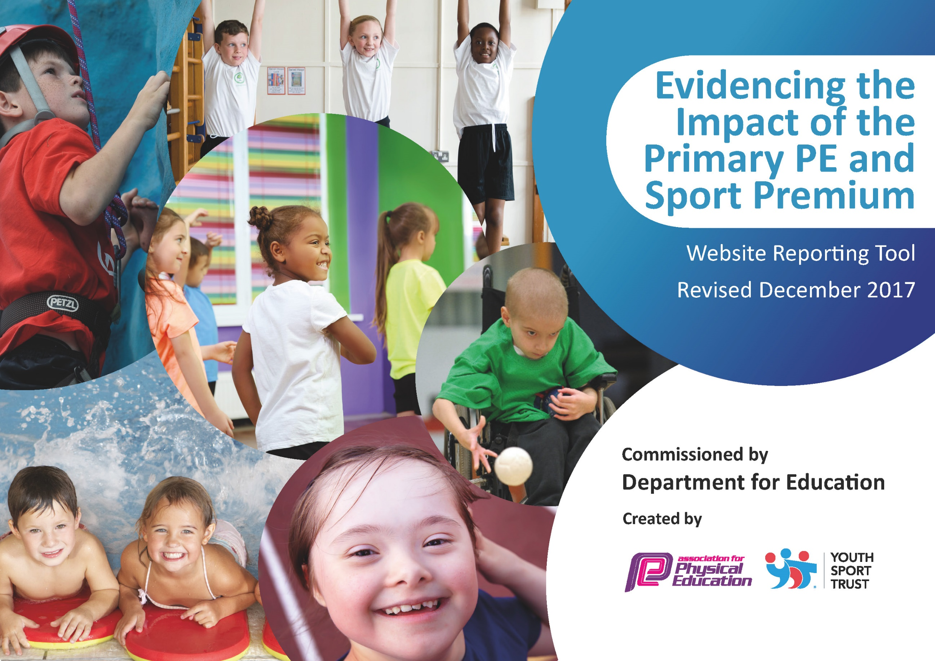

Schools must use the funding to make additional and sustainable improvements to the quality of PE and sport they offer. This means that you should use the Primary PE and Sport Premium to:

- develop or add to the PE and sport activities that your school already offers
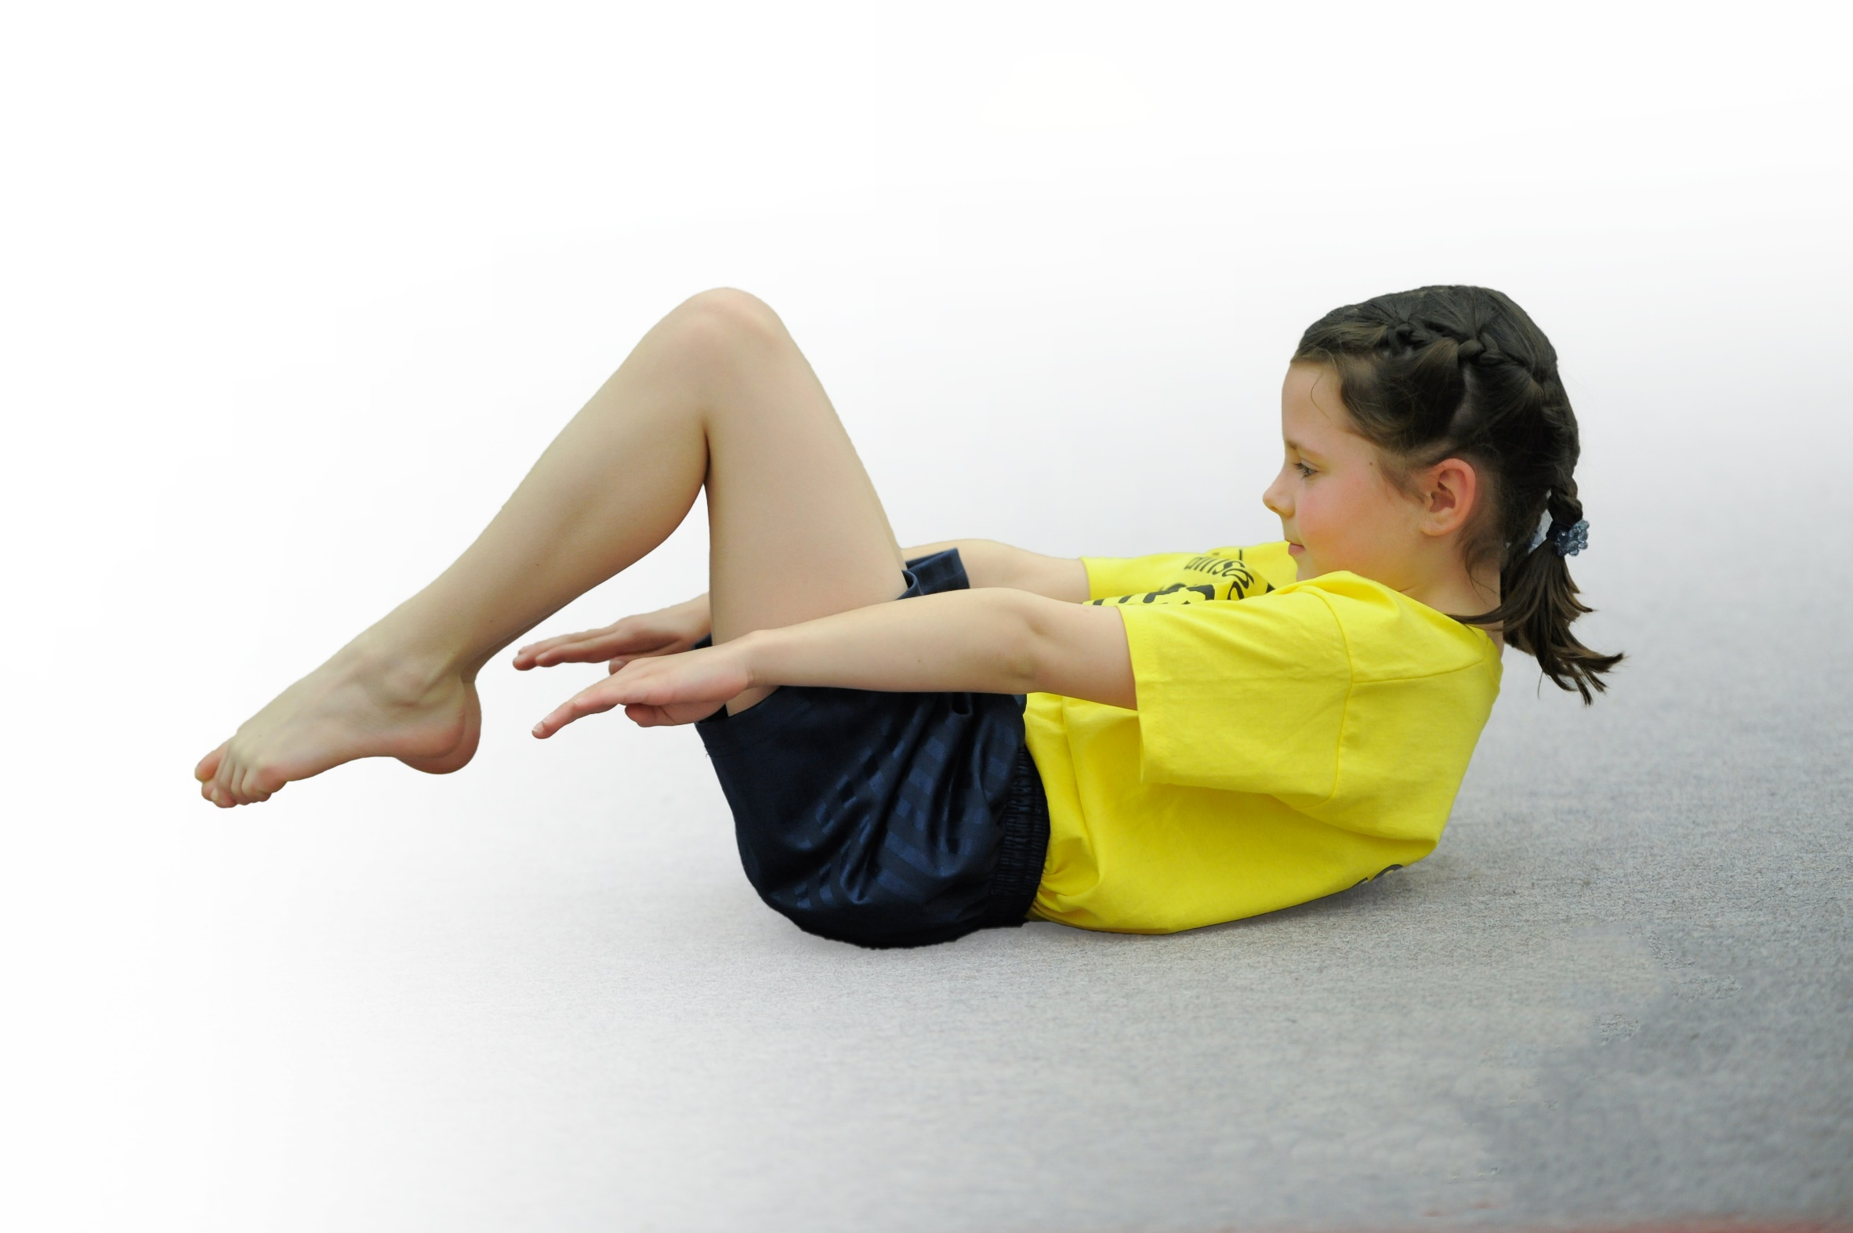
- build capacity and capability within the school to ensure that improvements made now will benefit pupils joining the school in future years

Please visit gov.uk for the revised DfE guidance including the 5 key indicators across which schools should demonstrate an improvement. This document will help you to review your provision and to report your spend. DfE encourages schools to use this template as an effective way of meeting the reporting requirements of the Primary PE and Sport Premium.

We recommend you start by reflecting on the impact of current provision and reviewing the previous spend.
Under the Ofsted Schools Inspection Framework, inspectors will assess how effectively leaders use
the Primary PE and Sport Premium and measure its impact on outcomes for pupils, and how effectively governors hold them to account
for this.

Schools are required to publish details of how they spend this funding as well as on the impact it has on pupils’ PE
and sport participation and attainment.
We recommend regularly updating the table and
publishing it on your website as evidence
of your ongoing review into how you are using the money
to secure maximum, sustainable impact. To see an example of how to complete the table please click HERE.
Support for review and reflection - considering the 5 key indicators from DfE, what development needs are a priority for your setting and your students now and why? Use the space below to reflect on previous spend, identify current need and priorities for the future.

Key achievements to date: | Areas for further improvement and baseline evidence of need:
Key Indicator 1. The engagement of all pupils in regular physical activity- kick starting healthy lifestyles  - Our children continue to engage in avariety of outside of school activities. We have 78% of children involved in continuing provision with clubs beyond Sharneyford. The remaining children are encouraged to join in-school sports clubs that take place bi-weekly after school.  - We have, once again, sent children to train as Sports Ambassadors. These are year 5 pupils who then team up with the previous years’ ambassadors to create the Sports Leaders. There leaders engage others in active play, run competitions at break times and help in the running of the Change for Life club  - Children are taught in PSHCE lessons and in Science the importance of a healthy diet and the impact of sugar on the body. This is coupled with ongoing training in PSHCE so that our children are in receipt of high quality lessons in wellbeing and healthy lifestyles.  - Mr Greenwood and Mrs Handley attended KS2 and EYFS/KS1 training at the start of 2019 to engage in new ideas for the delivery of PE across school; creating a whole school approach to the teaching of PE  - All classes regularly complete the daily mile.  Key Indicator 2 The profile of PE and sport being raised across the school as a tool for whole school improvement; Key Indicator 3: Increased knowledge and skills of all staff in teaching PE and sport.  - Mr Greenwood (Class 3 teacher and PE Co-ordinator) is a PE subject specialist who teaches PE across the entire KS2 cohort.  - Money is allocated to the Rossendale Leisure Trust who provide highly qualified sports coaches that work with our class teachers to provide high-quality PE provision.  - Our teachers follow the Lancashire Scheme of Work for PE.  - Our school offers a huge range of after school sports clubs.  - Links established with Ski Rossendale and Fearns Equestrian.  - LG runs Change for Life club every Friday working with the whole school; aided by the Sports Leaders.  - Staff have been trained in EYFS, KS1 and in KS2 schemes of work.  - PE leader is a subject specialist who teaches in all year groups of KS2  - Gymnastics coach works with KS1 teacher to support the delivery of high quality PE.  Covid 19  - Sports week was cancelled this year due to the Covid-19 pandemic. In spite of this, the school offered daily PE lessons (online) to all classes- focusing on the complete range of movements that underpin a high range of sports. This was offered through the Lancashire Team for School Sports.  - We offered our children the chance to compete in an online remote sports day.  - For the above, Sharneyford received the Sainsburys Virtual School Sport award.  Key Indicator 4: Broader experience of a range of sports and activities offered to all pupils  - Ski Rossendale lessons continue to be well attended.  - Fearns equestrian also continues to be well attended.  - 4 PE ambassadors were selected and attended a leadership course in October. They show excellent responsibility and commitment in this role.  - Informal feedback shows that the majority of our children are involved in active playtimes. Furthered by Change for life club every Friday.  - Total Dance coaches teach in Spring term every Wednesday with KS2 and have taught (alongside the class teacher) in KS1 on a Thursday.  - Funtastic Yoga was well attended and is given excellent feedback from our children. | Impact  Our children develop pride for our school and continue to compete well in sports both inside and outside of school. Our children are always given the opportunity to compete in regular sports and the number of children attending outside school sports is increasing. This allows our children to be proud of their sporting achievements.  Note- this above impact was true up to the onset of the Covid-19 pandemic.  Areas for improvement- In school coaching.  A conversation with the Rossendale Leisure Trust has taken place to ensure that the sports next year after school are more appropriate to the age, need and enjoyment of our pupils. We will not seek any coaching during the Autumn 1 phase of next year but will look forward to working with them to put into practice our ideas resulting from the aforementioned dialogue form Autumn 2 onwards.  Impact  Less active children are highlighted and are encouraged through our Change for Life club. Active play times and Sports Leader led play ensures that all our children are mobile. All staff understand the importance of activity and how this contributes to successful learning.  We will aim to continue into the 20/21 school year with the same goals as the school year of 19/20. The impact above is true up-to March 2019 and the onset of Covid-19. Without a full year to assess properly the needs for further improvement, we will keep the same links, offer the same opportunities and keep the same commitment from staff in order to fully gauge which improvements may need to be made.  Impact  This has impacted upon our pupils as we now have children who compete in other sporting opportunities- these include children who engage in: skiing, yoga, swimming, boxing, archery, equestrian and skiing.  We will continue to monitor these links throughout 2020-21 and make an informed decision on their continuation due to their popular nature with our children and the fact that they deliver an excellent opportunity for a broader range of sports.
DfE Key Indicator 5: Increased participation in competitive sport

The participation in sports this year has been difficult. Our most popular and well-attended sports – tri-golf, cross-country, the swimming gala were all cancelled due to Covid-19. We therefore have had little opportunity to engage in competitive sport on a school level. We will look to competing more during 2020-21 without the hindrance of the Covid-19 pandemic.

Meeting national curriculum requirements for swimming and water safety | Please complete all of the below*:
What percentage of your current Year 6 cohort swim competently, confidently and proficiently over a distance of at least 25 metres? | % 50 (March 2019)
What percentage of your current Year 6 cohort use a range of strokes effectively [for example, front crawl, backstroke and breaststroke]? | % 50 (March 2019)
What percentage of your current Year 6 cohort perform safe self-rescue in different water-based situations? | % 50 (March 2019)
Schools can choose to use the Primary PE and Sport Premium to provide additional provision for swimming but this must be for activity over and above the national curriculum requirements. Have you used it in this way? | Yes
*Schools may wish to provide this information in April, just before the publication deadline.

Action Plan and Budget Tracking
Capture your intended annual spend against the 5 key indicators. Clarify the success criteria and evidence of impact that you intend to measure to evaluate for students today and for the future.

Academic Year: 2019/20 | Total fund allocated: £16,689 | Date Updated: 29/7/2019
Key indicator 1: The engagement of all pupils in regular physical activity – Chief Medical Officer guidelines recommend that primary school children undertake at least 30 minutes of physical activity a day in school |  |  |  | Percentage of total allocation:
 |  |  |  | 32.25%
School focus with clarity on intended impact on pupils: | Actions to achieve: | Funding allocated: | Evidence and impact: | Sustainability and suggested next steps:
To maximize the engagement of pupils in high quality PE of at least 2 hours so that pupils are given the opportunity to enjoy and prosper in Physical Education. | - Update the quality of provision by updating the playtime equipment and the PE equipment.  - Provide specialized coaches to work with class teachers providing continued CPD in lesson time  - RLT membership | 1)£835.90  2)£1947  3)£2540 | Continuation of playground and equipment updates.  Coaching for 3 hours per half term.  Access to CPD and Lancashire Schemes of Work | Schemes of work valid for 4 years and an essential tool for the implementation of a whole school PE approach.  Coaches to work with teachers to increase the knowledge and confidence of teachers- leading to continued enrichment of our childrens’ experiemces.
Key indicator 2: The profile of PE and sport being raised across the school as a tool for whole school improvement |  |  |  | Percentage of total allocation:
 |  |  |  | 2.61%
School focus with clarity on intended impact on pupils: | Actions to achieve: | Funding allocated: | Evidence and impact: | Sustainability and suggested next steps:
For children to understand the impact of leading an active and healthy lifestyle so that they can go forward making the correct decisions in regards to healthy lifestyles. | - Outdoor education provision and resources  - Awards  - Other CPD | 1)£280.14  2)£106.63  3)£50 | Forest school leader trained in 2018-19 and now holds 1 lesson per class, per half term.  Last years’ report shows a 39.5% spend in this area compared to 2.61% this year. | Forest school continues to be popular and gaining awards from outside bodies. There has been no need to spend much further in this area.  Woodland trust wards Bronze and Silver gained.  Next steps: to look into an online recording and assessment system for the the whole school.

Key indicator 3: Increased confidence, knowledge and skills of all staff in teaching PE and sport |  |  |  | Percentage of total allocation:
 |  |  |  | 5.54%
School focus with clarity on intended  impact on pupils: | Actions to achieve: | Funding  allocated: | Evidence and impact: | Sustainability and suggested  next steps:
To increase confidence, knowledge and skills of KS1 and 2 staff in teaching PE and sport so that all staff are up-to-date with current initiatives and are able to implement high quality PE for our pupils. | - Investment in PSHE scheme to increase the knowledge and impact of teaching wellbeing and nutrition.  - Amaven membership  - LCC professional learning membership | 1)£150  2)£426  3)£350 | New scheme implemented and well used across school. Children have increased knowledge of wellness and nutrition.  Ongoing monitoring and assessment.  Staff trained in EYFS/KS1/KS2 schemes | New scheme will continue into the new year and carry on with its successful usage.  Monitoring incomplete due to COVID 19. Will use again next year and report upon its impact.  Trained staff in each Key Stage.
Key indicator 4: Broader experience of a range of sports and activities offered to all pupils |  |  |  | Percentage of total allocation:
 |  |  |  | 57.25%
School focus with clarity on intended  impact on pupils: | Actions to achieve: | Funding  allocated: | Evidence and impact: | Sustainability and suggested  next steps:
Enable a broader range of sports to be offered that are pertinent to the needs and opportunities of our children so that our children are able to benefit from the exploration of sports that are broader than generic school sports. | 1)Skiing  2)Equestrian  3)Yoga  4)Dance  5)Swimming  6)Martial arts  7)OAA  8)Football development  9)Boxercise  10) Hoola hooping  11) Cricket | 1)£1500  2)1575  3)£800  4)£648  5)£2461  6)£956  7)£300  8)£300  9)£590  10)£175  11)£250 | Our children are given a unique opportunity to learn how to ski and also how to ride and care for horses. The skiing and Equestrian still proves largely popular with our pupils and this relationship between school and provider will carry on into the new year. | COVID 19 and its impact will mean that we will continue with each of these sports again next year and assess each by their individual impacts.
Key indicator 5: Increased participation in competitive sport |  |  |  | Percentage of total allocation:
 |  |  |  | 0.0%
School focus with clarity on intended  impact on pupils: | Actions to achieve: | Funding  allocated: | Evidence and impact: | Sustainability and suggested  next steps:
To enable more pupils to participate in school competitions and fixtures across a broad range of sports so that our children are proud to belong to a team and learn how to be a team player. | N/A this year due to the Covid-19 pandemic.

