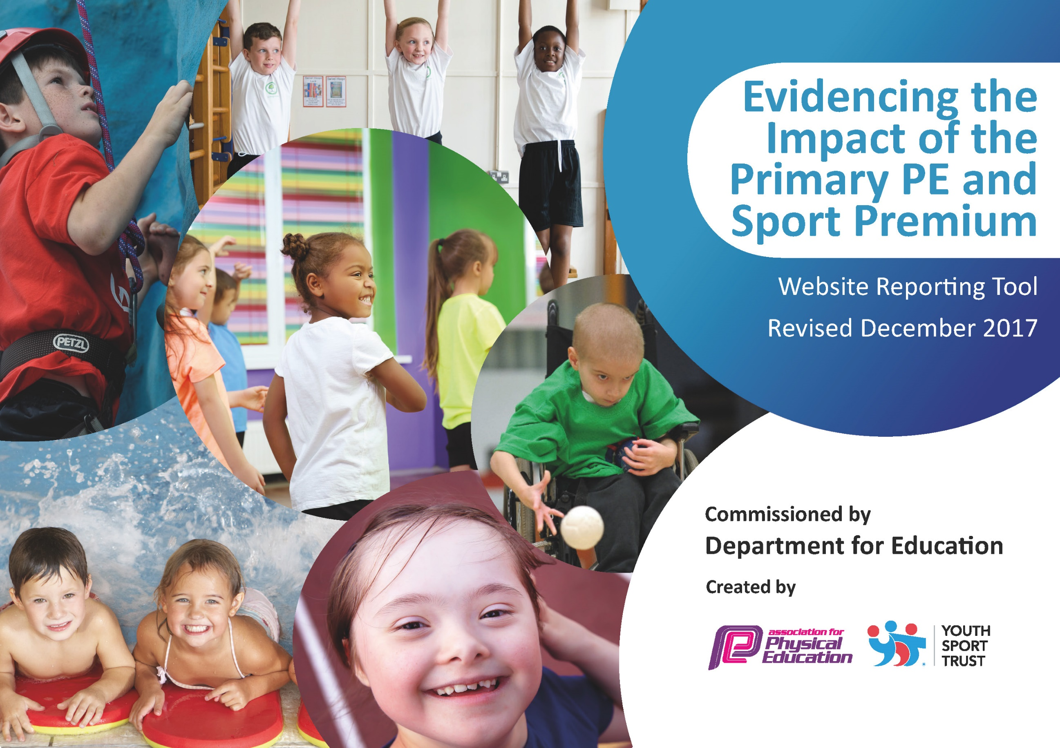

Schools must use the funding to make additional and sustainable improvements to the quality of PE and sport they offer. This means that you should use the Primary PE and Sport Premium to:

- develop or add to the PE and sport activities that your school already offers
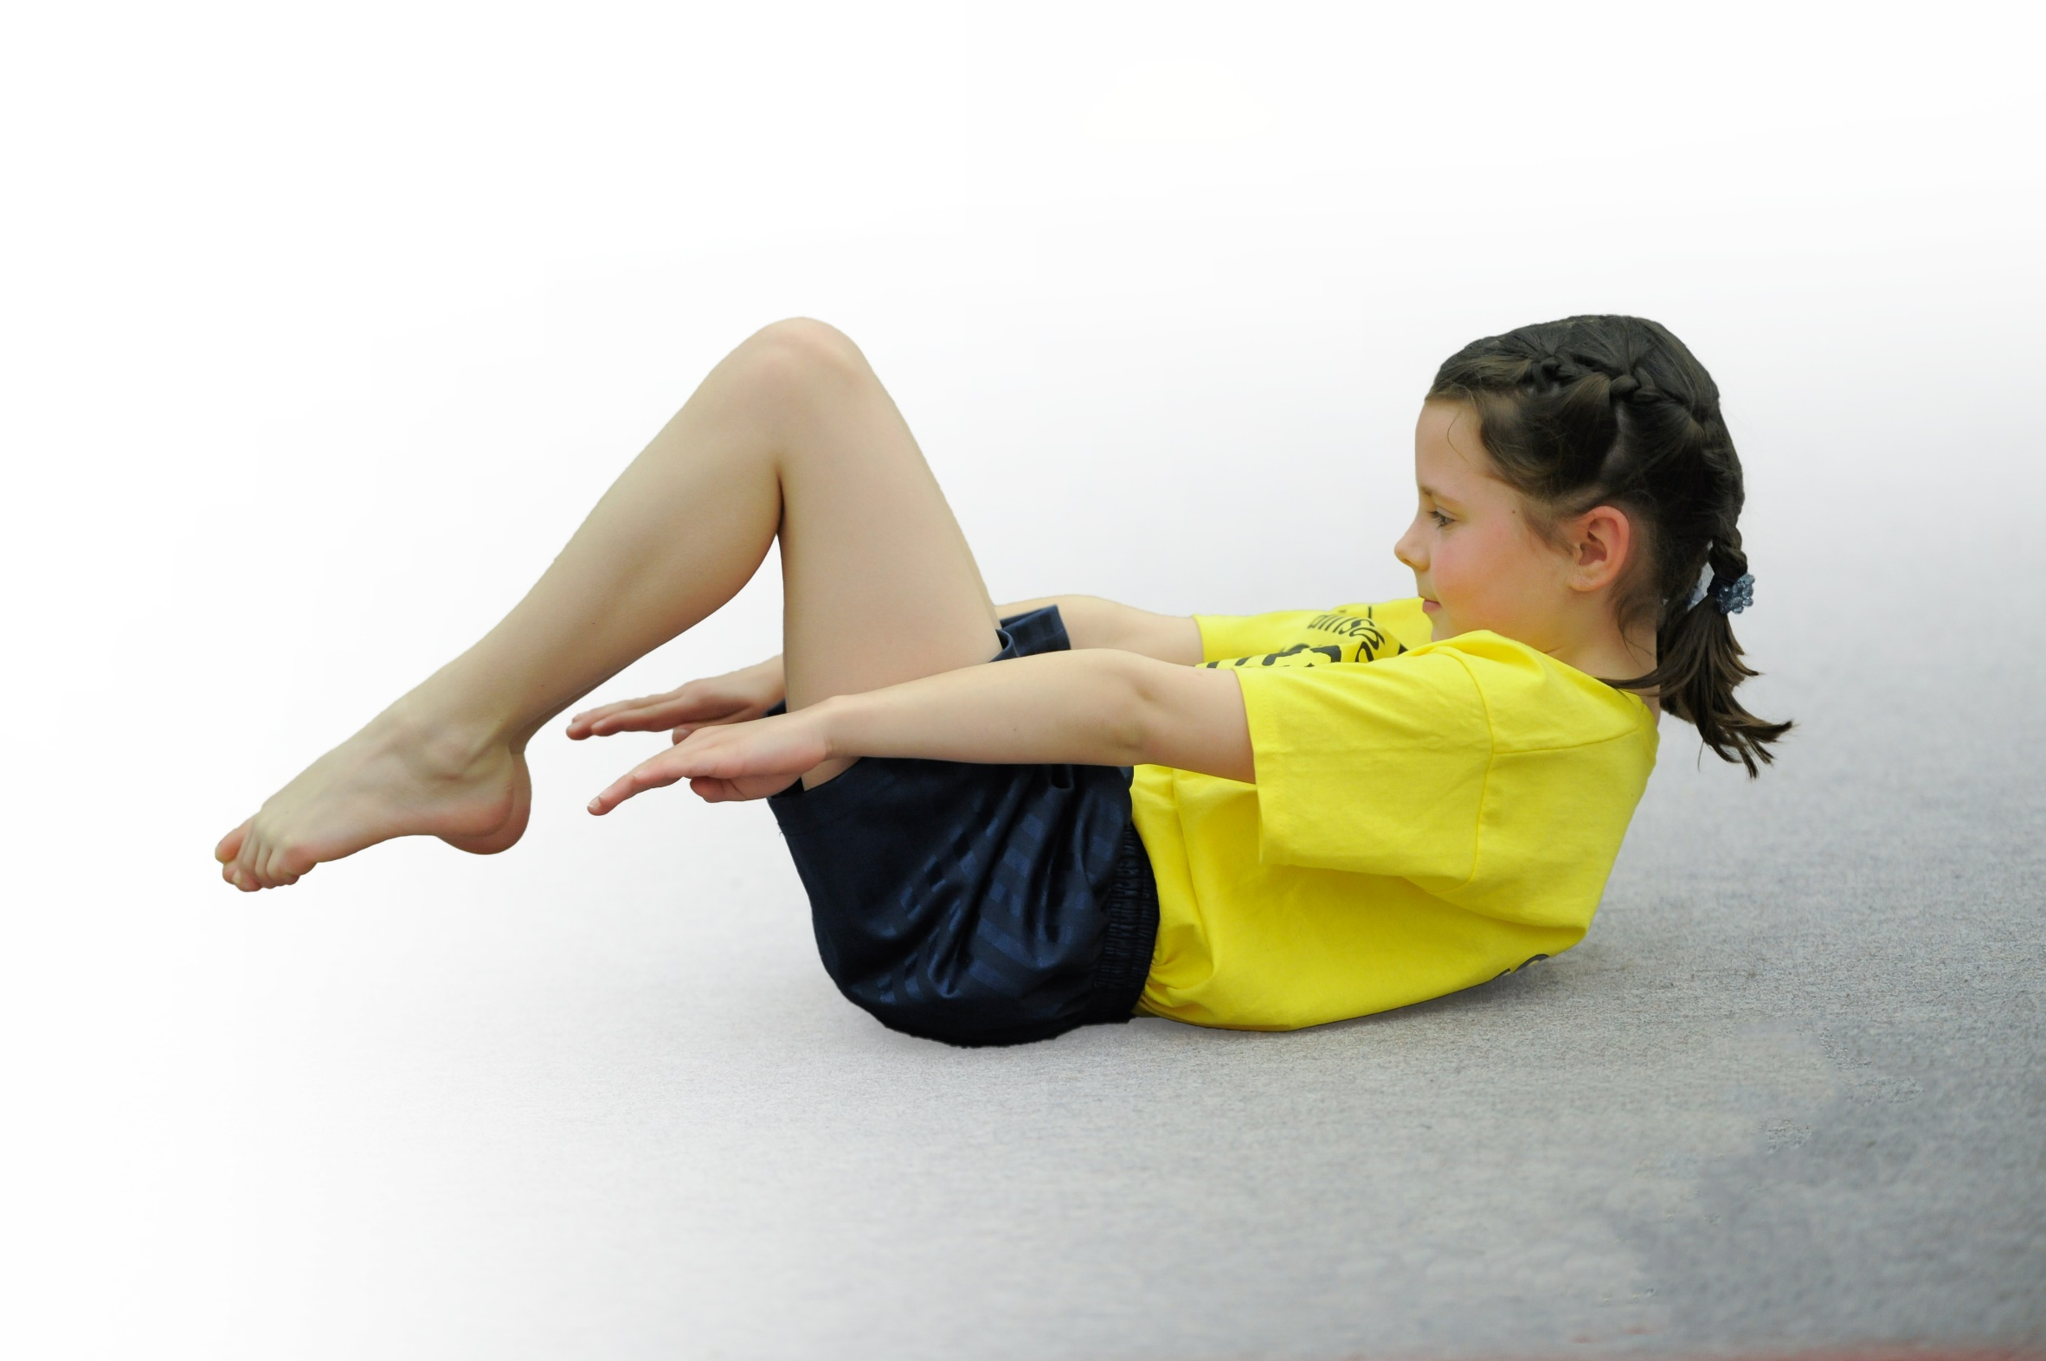
- build capacity and capability within the school to ensure that improvements made now will benefit pupils joining the school in future years

Please visit gov.uk for the revised DfE guidance including the 5 key indicators across which schools should demonstrate an improvement. This document will help you to review your provision and to report your spend. DfE encourages schools to use this template as an effective way of meeting the reporting requirements of the Primary PE and Sport Premium.

We recommend you start by reflecting on the impact of current provision and reviewing the previous spend.
Under the Ofsted Schools Inspection Framework, inspectors will assess how effectively leaders use
the Primary PE and Sport Premium and measure its impact on outcomes for pupils, and how effectively governors hold them to account
for this.

Schools are required to publish details of how they spend this funding as well as on the impact it has on pupils’ PE
and sport participation and attainment.
We recommend regularly updating the table and
publishing it on your website as evidence
of your ongoing review into how you are using the money
to secure maximum, sustainable impact. To see an example of how to complete the table please click HERE.
Support for review and reflection - considering the 5 key indicators from DfE, what development needs are a priority for your setting and your students now and why? Use the space below to reflect on previous spend, identify current need and priorities for the future.

Key achievements to date: | Areas for further improvement and baseline evidence of need:
Key Indicator 1. The engagement of all pupils in regular physical activity- kick starting healthy lifestyles  - Our children engage in a wide variety of outside of school activities- including from dance, football, dodge ball, rugby, swimming, archery, horse riding, boxing. Those who were found not to be currently engaging in outside sport are identified and encouraged to join one of our after-school coaching sessions; taking place every Monday and Wednesday. Activities include: Yoga, Gymnastics, Tri-Golf, Team games, fitness, athletics, football, netball, basketball.  - Mrs Greenwood (TA) attended sports ambassador training with two year 5 pupils. These pupils joined two year 6’s in school to create the School Sports Organising Crew (SSOC). Together these pupils help organize in school competitions, focused active playtimes and also help lead Mrs Greenwood’s Change for Life club that runs all year at Friday dinner time.  - Our school actively pursued and gained the Healthy Schools mark. Children are taught in PSHCE lessons and in Science the importance of a healthy diet and the impact of sugar on the body.  - Active maths and active literacy is present across all classes. Mr Greenwood (PE co-ordinator) attended training for both during the 2018-19 school year.  - All classes regularly complete the daily mile.  Key Indicator 2 The profile of PE and sport being raised across the school as a tool for whole school improvement; Key Indicator 3: Increased knowledge and skills of all staff in teaching PE and sport.  - Mr Greenwood (Class 3 teacher and PE Co-ordinator) is a PE subject specialist who teaches PE across the entire KS2 cohort at least once per class, per week. This ensures high quality provision in present across all of KS2.  - Money is allocated to the Rossendale Leisure Trust who provide highly qualified sports coaches to coach the children for 50% of the PE lessons for each class in KS2.  - New long term plans for KS1 and KS2 are in place to help focus lessons on fundamental movement skills and the actions and sequencing of movement.  - Our school offers a huge range of after school sports clubs as detailed in Key Indicator 1  - Links established with Blackburn Rovers FC who run community coaching during the summer term.  - LG runs Change for Life club every Friday working with the whole school.  - Staff have been trained in EYFS and in KS2 schemes of work, with a KS1 scheme of work course to be planned in for all next year.  - Planning is taken from Lancashire Schemes and all staff use these to support teaching.  - PE leader is a subject specialist who teaches in all year groups of KS2  - Gymnastics coach works with KS1 teacher to support the delievery of high quality PE.  - Sports week completed with all children engaging in Boxercise, Martial arts, Dance and Basketball.  - Leah Barrow- Gb athlete performed a presentation and worked with groups of all ages across school.  The impact of this is that children have a renewed enthusiasm for their work- knowing what they need to do in lessons and the changes they need to make at home in order to lead an active and healthy lifestyle. We have seen an increased level of achievement against the nationa curriculum objectives; supported by our use of current assessment systems.  Key Indicator 4: Broader experience of a range of sports and activities offered to all pupils  - We have made contact with Ski Rossendale and have been able to offer children a ski lessons package after school with private tuition; our children take lessons in groups of 12 for 1 hour each Tuesday in blocks of 6 lessons.  - We have made contact with Fearns equestrian centre who have been able to help us offer a package of horse riding lessons.  - 4 PE ambassadors were selected and attended a leadership course in October. They show excellent responsibility and commitment in this role.  - Informal feedback shows that the majority of our children are involved in active playtimes. Furthered by Change for life club every Friday.  - Total Dance coaches teach in Spring term every Wednesday with KS2  - Sports week completed with all children engaging in Boxercise, Martial arts, Dance and Basketball.  - Funtastic Yoga is well attended.  This has impacted upon our pupils as we now have children who compete in other sporting opportunities- these include children who engage in: skiing, dodgeball, swimming, boxing, archery, equestrian and skiing. | Cricket club wasn’t well attended this year and will need to be actioned next year in order to raise participation in this sport.  During the mornings at the start of the year a Zumba club was attended by children- this decreased in numbers and there is a plan to meet with Total Dance Ltd to see whether this can be set up again with an action plan to increase numbers.  Inactive children to be targeted for focused play times.  PE specialist is given time to attend after-school competitions that are run by the RLT. Other adults could be utilized to help with the running of competitions and therefore helping to raise the profile of PE across the whole of school.  Improve the strategy for reporting and publishing the sporting achievements/participation across school- blog, school website?  Use Amaven assessments to identify strengths and weaknesses in children and use this data to inform planning- all staff need to be aware of its benefits and need to be trained on its successful usage.  Allow parents to have access to Amaven logins where they can see their own child’s data and also have access to at home activities and exercises that are tailored to their individual fundamental movement skills.  Train new sports leaders externally to continue with the sports ambassador program.  Continue to uphold links with skiing and horse riding.  Develop activity stations at lunchtime and break times to help structure play times more effectively. Benefits to include the development of fundamental movement skills, core motor skills, fitness and mental wellbeing.
DfE Key Indicator 5: Increased participation in competitive sport  - Separate KS1 and 2 sports days days were planned for in advance with all children being given a greater opportunity to participate.  - We have competed in football, swimming, cross-country, tri-golf, orienteering and dodgeball- all teams have enjoyed this and we have larger numbers that want to participate. | Allow children more opportunities to participate in sports at school by organizing more release time for AG or for other staff members to go to competitions.  Possibly look at EKS taking KS1 children to more competitive events.

Meeting national curriculum requirements for swimming and water safety | Please complete all of the below*:
What percentage of your current Year 6 cohort swim competently, confidently and proficiently over a distance of at least 25 metres? | % 80
What percentage of your current Year 6 cohort use a range of strokes effectively [for example, front crawl, backstroke and breaststroke]? | % 80
What percentage of your current Year 6 cohort perform safe self-rescue in different water-based situations? | % 80
Schools can choose to use the Primary PE and Sport Premium to provide additional provision for swimming but this must be for activity over and above the national curriculum requirements. Have you used it in this way? | No
*Schools may wish to provide this information in April, just before the publication deadline.

Action Plan and Budget Tracking
Capture your intended annual spend against the 5 key indicators. Clarify the success criteria and evidence of impact that you intend to measure to evaluate for students today and for the future.

Academic Year: 2018/19 | Total fund allocated: £16,578 | Date Updated: 5/7/2019
Key indicator 1: The engagement of all pupils in regular physical activity – Chief Medical Officer guidelines recommend that primary school children undertake at least 30 minutes of physical activity a day in school |  |  |  | Percentage of total allocation:
 |  |  |  | 29.8%
School focus with clarity on intended impact on pupils: | Actions to achieve: | Funding allocated: | Evidence and impact: | Sustainability and suggested next steps:
To maximize the engagement of pupils in high quality PE of at least 2 hours | - Update the quality of provision by updating the playtime equipment and the PE equipment.  - Provide specialized coaches to work with class teachers providing continued CPD in lesson time  - Other coaching | 1)£1400  2)£3000  3)£550 | Updates to playground equipment and lesson time equipment.  Coaching for 3 hours per half term | Investment in tri-golf equipment lead to a 2nd place finish out of all Rossendale schools.  Association with RLT will continue.
Key indicator 2: The profile of PE and sport being raised across the school as a tool for whole school improvement |  |  |  | Percentage of total allocation:
 |  |  |  | 39.5%
School focus with clarity on intended impact on pupils: | Actions to achieve: | Funding allocated: | Evidence and impact: | Sustainability and suggested next steps:
For children to understand the impact of leading an active and healthy lifestyle. | - Amaven assessment system  - Outdoor education provision  - Video equipment for assessment and improving performance  - GB athelete visit and CPD | 1)£300  2)£1000  3)£4250  4)£1000 | Ongoing Amaven subscription  Training and equipment of forest school leader.  Ipads are used in lessons so that children can aseess and improve their own performance. | To continue  We are able to offer our children structured, trained forest school lessons without relying on outside agencies. The school has achieved the silver award for this.

Key indicator 3: Increased confidence, knowledge and skills of all staff in teaching PE and sport |  |  |  | Percentage of total allocation:
 |  |  |  | 4.2%
School focus with clarity on intended  impact on pupils: | Actions to achieve: | Funding  allocated: | Evidence and impact: | Sustainability and suggested  next steps:
To increase confidence, knowledge and skills of KS1 and 2 staff in teaching PE and sport. | - Amaven challenge day- focusing on the importance of physical literacy and how it can be used as a basis for lessons  - RLT and Total Dance ltd providing support for teachers in teaching lessons | 1)£ 400  2)£300 | Amaven is used to assess children in their physical literacy and identify gaps which inform planning.  Coaching in Gymnastics and Dance to help teachers learn in specialized areas of sport. | Amaven will be used again in 2019-20  We will use dance again but not the gymnastics as now class teachers are more confident in the delivery of gymnastics
Key indicator 4: Broader experience of a range of sports and activities offered to all pupils |  |  |  | Percentage of total allocation:
 |  |  |  | 30%
School focus with clarity on intended  impact on pupils: | Actions to achieve: | Funding  allocated: | Evidence and impact: | Sustainability and suggested  next steps:
Enable a broader range of sports to be offered that are pertinent to the needs and opportunities of our children | 1)Equestrian  2)Ski Rossendale  3)Total Dance ltd  4)Funtastic Yoga  5)Forest school  6)Ash Randall Freestyle  7)RLT | 1)£1920  2)£850  3)£1200  4)£320  5)£70  6)£350  8)£275 | 60% of year 5 and 6 pupils  55% of year 3 and 4 pupils  33% of reception, year 1 and year 2 pupils. 49% of the school overall have learnt to ride horses on the road and how to care for the horses.  57% of the school have learnt to ski by maintaining links with our local dry ski slope center.  All of KS2 pupils have access to dance lessons provided by professional dance coaches offering coaching in street dance, zumba and period dance | These links will be maintained for a further year. It is offering our children a chance wihich is pertinent to the area in which they live. A number of children have gone on to compete in dressage and achieved highly.  Children have gone on to attend weekly lessons on dry ski slope and have been invited to train with the local race team.  Maintain these links next year. The number of children dancing outside of school has increased. We have one member in school who won a European title.  We have now our own trained forest school leader.  Links with the RLT will be maintained.
Key indicator 5: Increased participation in competitive sport |  |  |  | Percentage of total allocation:
 |  |  |  | 0.7%
School focus with clarity on intended  impact on pupils: | Actions to achieve: | Funding  allocated: | Evidence and impact: | Sustainability and suggested  next steps:
To enable more pupils to participate in school competitions and fixtures across a broad range of sports | 1)Transport to competitions | 1)£145 | Funding for this isn’t massively needed as we don’t need to pay to cover for any release time as Ag attends all competitions after school. We don’t need to pay for transport as, with a small school, we can rely on fantastic parent involvement. | Funding again in this area will be minimal.

