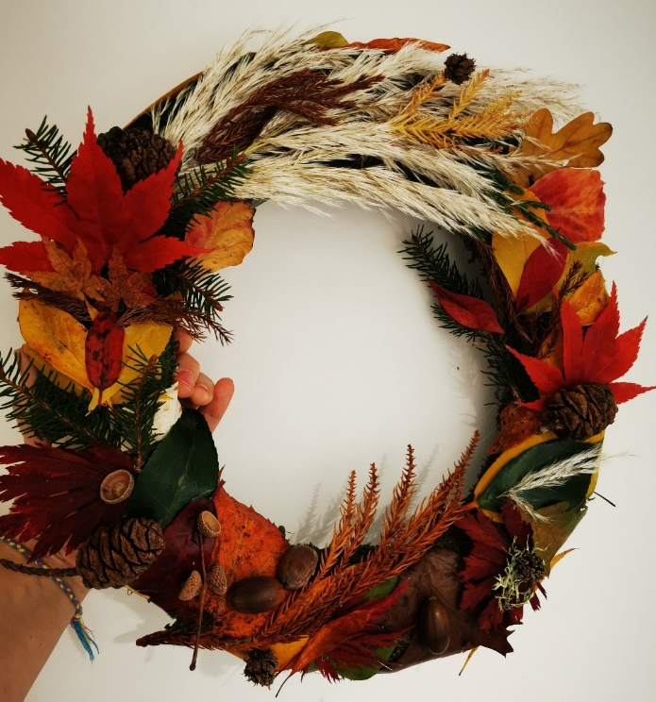

Make an autumn wreath or door ring. It's so easy!
What do you need? Just take a little walk with your small people and look out for nature's harvest. You'll find acorns, red and golden leaves, lichen, cones, ornamental grasses, evergreens, berries and maybe even feathers. Obviously teach your children to be wary of putting their fingers in their mouths and certainly don't let them attempt to eat any of their treasures.
Next, either buy or make a ring template. You can buy wreath rings or you can bend some hazel or willow whippy twigs into a circle and secure them using wire or twine.
Then you might want to coat the autumn leaves in a protective layer of Vaseline - or even give them a quick squirt of hairspray.This will delay the onset of 'leaf crisp'!
Simply attach your autumn leaves, fruits, foliage and fluff to the ring template using florist's wire, elastic twine or even a glue gun. This is a great task to do with the children. They will love to spread everything out on a tabletop and enjoy putting the different items together. Aim to create contrasting colours and textures.

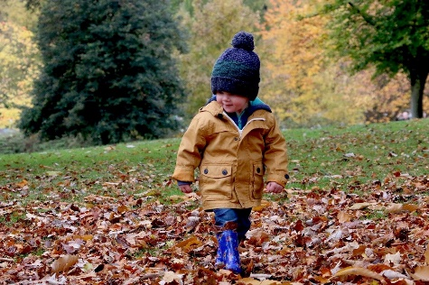

Organise a simple treasure hunt outdoors.
It could be as simple as going to collect a list of objects. Take your little explorers to find a cone from a conifer, a shell, a smooth stone or pebble, a feather, a red leaf, a yellow catkin or a white flower? Older children could follow a series of picture or written clues, each one leading to the next clue and ultimately they will find some 'treasure'.

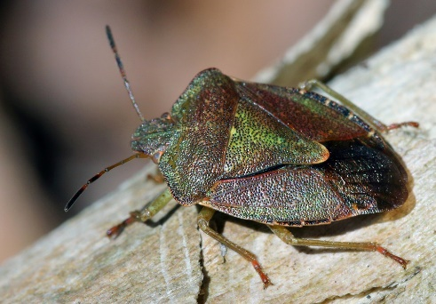

Look in detail at some mini-beasts
Arm them with a magnifying glass and a drawing pad with pencils. You can find as much in a town or city as you can in the countryside if you look closely enough. Turn over stones (carefully), look at plants to see what might be hiding there, peep into flower beds, notice birds and teach the little people to be patient and caring. Even in one square metre of grass you can find plenty of life. Ants, wasps, flies, maybe a butterfly or even a frog if you are lucky. Encourage the children to draw what they see. Photograph it so you can re-live the experience at home later. You could also research some interesting facts about the creatures they find. Or you might want to identify birds that are feeding from the bird table.

Rhyming words, counting games and I-Spy
Autumn-inspired rhyming words can be a lot of fun. What rhymes with tree? How about rain? How many conkers can you see? Come rain or shine, there are plenty of games that can happen indoors or out. Older children can match the fruit to the tree and even guess the tree from a leaf. They could even try some leaf-rubbing with a wax crayon, a beautiful leaf and some white paper.
Ignite the flame of nature-loving in your children and enjoy the outdoors during half term.

